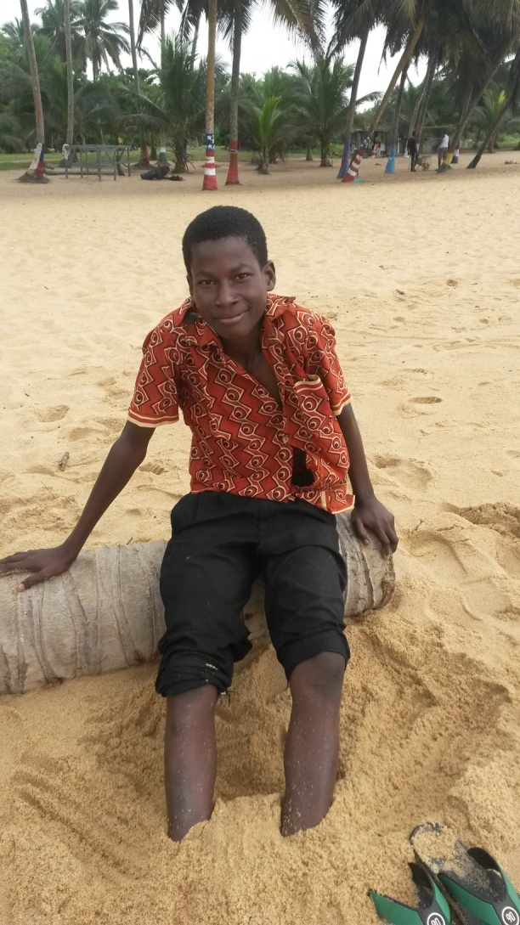For worldsupporter, I have done an interview with a local boy in Ghana. His name is Fuseini Seidu and he is 16 years old, the same age as me. I met him on the beach in Accra, where I, and the other volunteers I went to Ghana with, were enjoying our last days in Ghana. Esmée and I were searching for shells to take home, when Fuseini came to us and showed us very big shells. He said he found them at the rocks and he told us he would show us where he found them, so we could find them too. This is how our conversation started.

Fuseini told me he has 7 brothers and 1 sister and he is the youngest. He has a twin brother, but he is not the only one with a twin brother… His mother got three twins! I found it very particular.

When I asked Fuseini if he thinks voluntary work is necessary in Ghana, he answered me ‘no’. He thinks that the people in Ghana can fix everything themselves, but when I asked him why they don’t fix it then, he told me he didn’t know.

Fuseini goes to an international school in Cape Coast from Monday till Friday and in his free time he goes to the beach to go swimming, find shells and play soccer with ‘white people’. He told me that he has many ‘white’ friends from countries like Germany and he hopes he can visit them someday.

When I asked Fuseini where he lives he told me he lives in a hotel, because his father works there. But not the whole family lives there: he lives there with some of his brothers. The other brothers live with their mother in Accra or somewhere else.

Fuseini told me he can work a little sometimes, but sometimes he only earns 5 cedi’s a day. That’s equal to 1,19 euro. Sometimes he earns 15 cedi’s a day, that’s equal to 3,56 euro’s. It’s weird that I will earn that amount of money in one hour and he has to work a whole day for it. When he’s older, he wants to become a doctor or a taxi driver. He found the choice hard. When he really had to choose, he would prefer to be a doctor.

He didn’t know anything about the millennium development goals and he also didn’t know a lot about the world, so I couldn’t talk with him about that and discuss about it. But I found my conversation with him very inspiring and I won’t ever forget all the people I’ve met in Ghana.