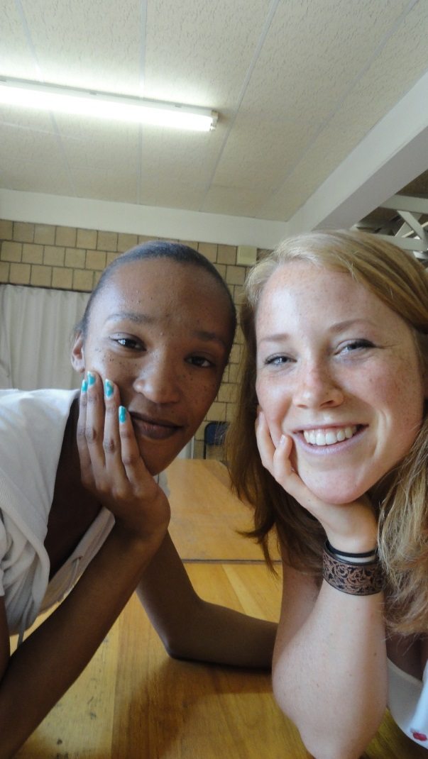**Interview with Mercia(24)**

Mercia is a women of 24 years old and is currently participating the ‘lifeskill course’. The course is meant for motivated but unemployed people. I met Mercia when I was joining one of the meetings. In this meeting the course was about Health. With several other participants we talked about the topics that were presented. At the end Mercia asked for my Facebook and so my idea of doing an interview also came up.

Mercia told me she really liked to do the interview and that is was also a way to practice talking to people. A few weeks later I met her again to do the interview. At 11:30 i arrived at Strelizzia Primary school to do an interview. We sat down in the staff room and started the interview.

Mercia is like me 24 years old and she currently lives with her mom and aunt in Bloemendal in Port Elizabeth (South Africa). She is the child from a ‘black’ farther and a ‘colored’ mother. Her mom works at the DA (Democratic Alliance) and her aunt is a social worker. When we talk about role models she mentions her aunt. Mercia describes her ant as being a very strong women and that she gave her a lot of good and useful advice and stimulants to be who she wants to be. Mercia always thought she had no siblings but after her father died, 5 years ago, she found out about 4 more siblings. She tells me it was really strange to find this out, the boys are I the age between 8 and 15 years old.

She is not in a relationship at the moment but she recently went on a really nice date with a guy. She tells me about women having relationships and getting pregnant at a very young age. ‘It’s very sad sometimes because it changes your life so much, and some girls end up raising their kids on their own. Mercia tells me she really want to have children in the future but that she is not in a hurry at all. ‘I want to be financially stable before she is getting a child and is able to take care of it.

We change the topic to her education. She tells me about her time at Astra primary school, where she had her best memory’s from her childhood. She describes that time as being very careless, a period that her parents gave her a lot of love and she had some very nice friends. She loved to write, as a child she didn’t talk a lot but writing essays was a way to express herself. This is consistent with her bad memory form her childhood, she recalls the lonely times, she was very shy and she didn’t have that much self-confidence.

When she was 13 years old she went to Chillé Highschool (PE) and after finishing at the age of 18 years old she started studying Human Resources. During that time it appeared the study didn’t suit her as much as she expected it to be. In the same period her grandfather and her father died and also because of that she stopped the study. To earn money she started working in a packaging company. After two years she quitted the job, and joined the Ready4Life life-skill course. In these ten weeks she wants to find out what she really wants and practice her social skills. The lifeskill course gave her the opportunity to practice speaking up and thinking about herself and her environment.

She tells me that she always wanted to study psychology which is also very closely related to her current interest: social work. Another thing she would really like to become is a teacher, preferably in a primary school.

**Dreams???**

She is dreaming all the time, about being independent and successful. Successful in this case means not necessary financially but in her work. She loves to see people enjoying the work they do. She wants to get up every morning being happy when she’s going to work.

She is currently unemployed but after the life skill course she is going to look for a job and maybe she will continue studying (maybe part time)

Her friends would say she is someone who likes to give advice, and help other people.

Her challenge is to not forget about herself. Mercia says it’s a challenge for her to put her own needs in the center instead of those from someone else.

As a bad habit she mentions that she does not like to take risks and rather stays in her comfort zone.

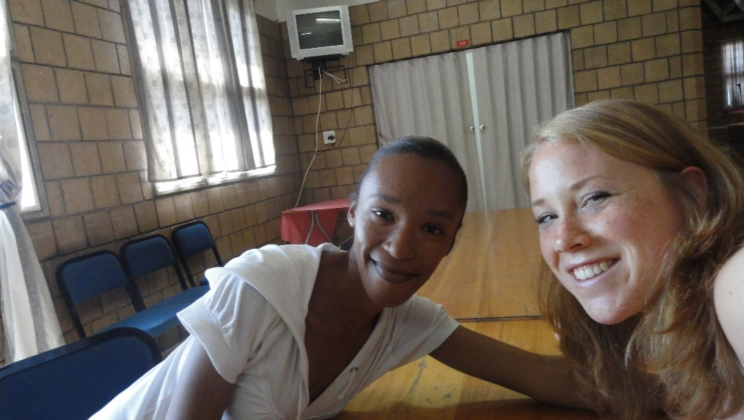

“Changing behavior is like new shoes, the more often you wear them the more comfortable it gets”

Reflection

The goal of this interview was to reflect on my life and to see how it differs from the life of a girl my age in South Africa. The first thing that is really clear is that Mercia grew up in a very loving environment.

I went, like every child in the Netherlands, to primary school and high school. After that I started my study Psychology.

Now by the time I’m 24 I’m master in science and since my 19th  I’ve lived separately from my parents. Next to my studies there was always time and money to do other nice activities like going out and going on a holiday. Now I’ve been in South Africa for 10 weeks I have to start looking for a job, just like Mercia. I really hope for her that she gets the chance to study either education or social work like she wants to.

I went to South Africa to see another culture and to meet other people. It was very new to me to be in het minority as a white person. Also to see how the ‘apartheid’ left his marks between people and in the differences in social-economic situations.

Its very inspiring to meet somebody like Mercia. I realized even more that I’m very lucky I was born in a western country like the Netherlands. Compared to young adults of my generation in the South Africa, everyone in the Netherland gets a certain level of education and had a legal right to get this. In South-Africa it’s all matter of money whether you get the chance to study or not. Although Mercia did not get all the chances I had in the past and all the chances I still have, she is very motivated to achieve something in her life. She, like many girls of her generation, had to stop studying because the money had to be spend on family affairs like a funeral.

I wish for her that she will be able to study further and either become a social worker like her aunt, or a teacher in a primary school.