
Masterclass Academic skills, an environmental case study.

An Eco-club initiative.

About the Masterclass
Indian students are more than any other in the world motivated to learn. We want to support these students and give them the opportunity to develop themselves to the utmost. Giving them the chance to work together with experts in the field and improve their academic skills that will be useful during further education and throughout their lives. This masterclass will teach a select group of 7th standard students new strategies in learning, by using an environmental case study. Students who pass the course successfully will obtain a certificate of accomplishment. Similar masterclasses have successfully been conducted in Tanzania and The Netherlands.
During this course the students will work together in groups of two on a final project. This gives students the chance to learn as they go. The project will be submitted for international competitions.

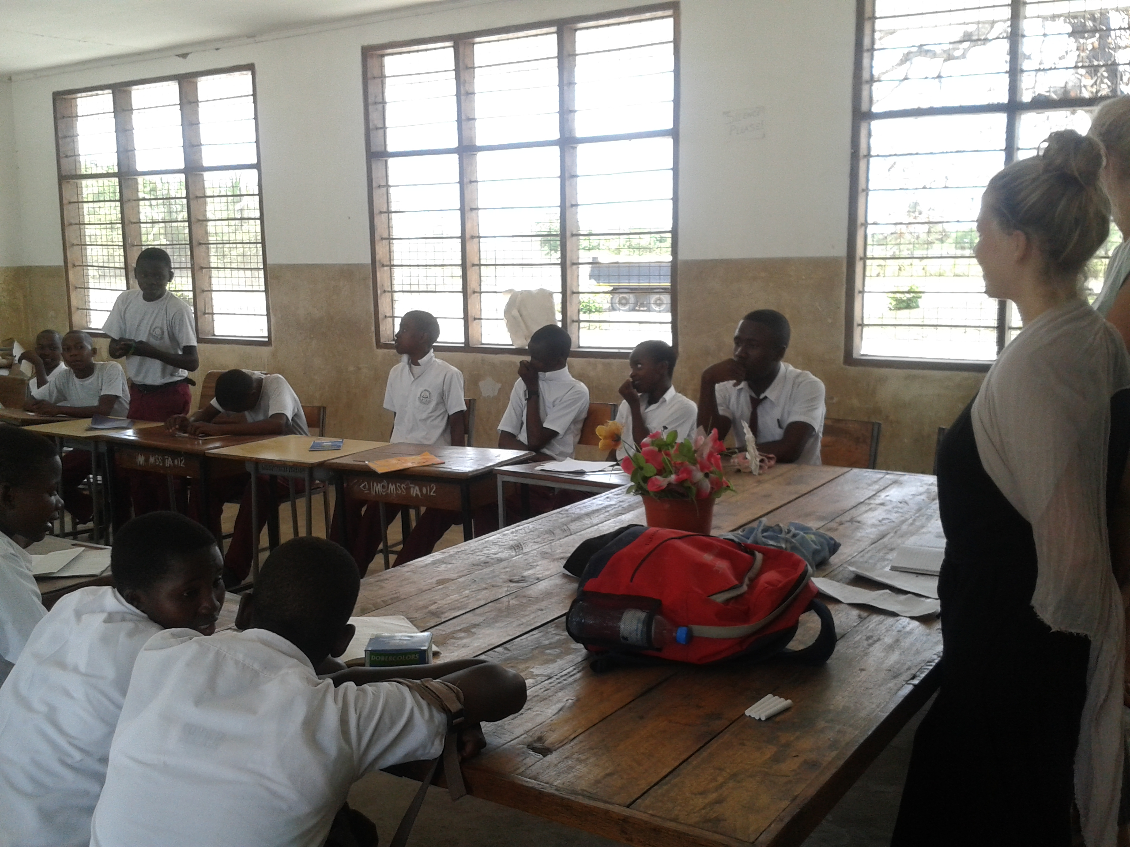
Course Syllabus
Academic Skills
-Presentation
-Debating
-Research
-Critical thinking

Course at a Glance
Duration: 8 weeks of study
Work load: 4-6 hours of work / week
Language: English

-Project work
-Learn strategies
Personal Skills
-Communication
-Self-organization
-Time management
-Team work
-Taking initiatives
Capstone Project
-International competition

Course format
In the first four weeks of the Masterclass the students will be trained in all the academic skills needed to start up a new (research) project. Every week there will be lectures focused on different academic skills, in addition there will be hands on mini projects so that the theoretical part can be put into practice in a fun way. After these four weeks the students will work in groups of two on a capstone project. As the project continuous students will improve their academic skills to the utmost. At the end of the project the students will receive a certificate of accomplishment and their project will be taking part in an international competition.

Resources needed:
- Class room
- Copies of worksheets
- Students should be available at the given times

Benefits.

For the students:
-Students will improve their academic skills.
-Students will obtain a certificate.
-Students will build up an international network.
-Students will participate in an international competition.
-Students will learn how to start up projects.
-Students will improve their learning skills and strengthen their self confidence
-Students will improve their knowledge on environmental issues.
- The students will get support in the preparation for their further exams (e.g. in February)
- The students will gain new skills by being practically involved.
- The students will learn how to approach school tasks, deal with problems in more effective way (save of time and energy)
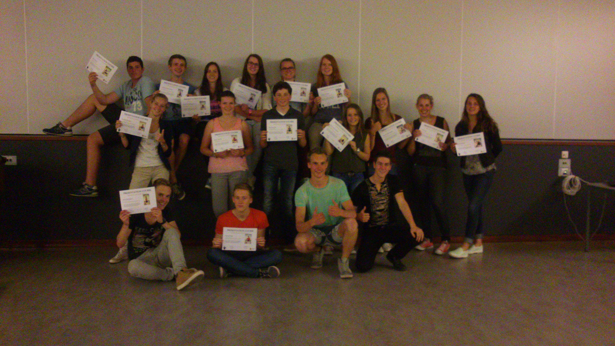
- The students will benefit from the fact that similar Masterclasses have already been run in different countries.

For the school
-The students of the school will perform better.
-The school can use this as excellent promotion material.
-The school gets a more professional outlook.
-The school will improve in working with students initiatives.
-The schools extends its international network.

Contact:

Manjula: Fslmanjula@gmail.com
8970038300
Max: Maxvandeursen@live.nl 8105264772
Laura: Laura.eckard@yahoo.de 9686826592

